Student Name: Rakyan Satrya Adhikara

Student ID: 219548135

Practical Task 6.1 (Task 03 & 04)

* Task 03 (UML Diagram)
  + The code:

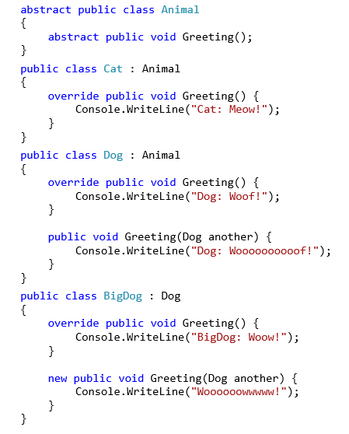

* + The UML diagram:

* Task 04
  + The code (with errors)

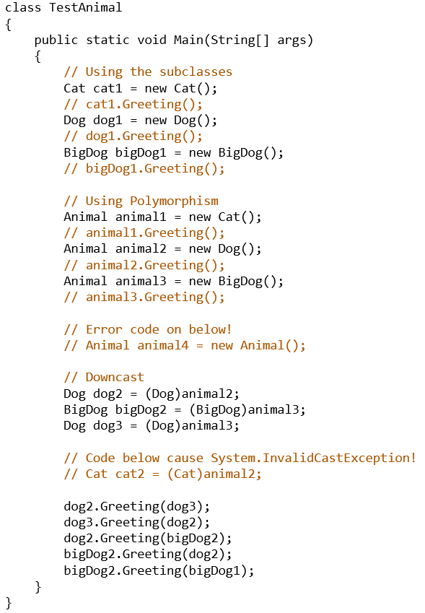

* + - Error #1:
      * Cause: program initiating a variable with an *abstract-type* of class
    - Error #2
      * Cause: System.InvalidCastException
      * Since Animal2 was originally a *dog*, the new Greeting function is not familiar with the *cat* type.
  + The output
    - Subclass part:
      * 
      * Meaning: it will print from the overridden functions
    - Polymorphism part:
      * 
      * Meaning: like the subclass, it will print from the overridden function
    - Downcast part:
      * 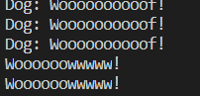
      * Meaning: Since the function was being called with a provided input (another *dog* variable), it will use the new *Greeting* function that have a *dog* parameter.